Model Evaluation and Reporting Strategy

Internship Project – Week 5 Deliverable


This Photo by Unknown Author is licensed under CC BY
Prepared By: Mudrika Mishra
Program: PGDM (Business Analytics)
Institute: Jaipuria Institute of Management
Project Area: Agribusiness Data Analysis
Date: October 2026

1. Introduction
Predictive models can help agribusiness organizations estimate crop yield and support better agricultural planning. However, developing a model is only one part of the analytical process. It is also necessary to evaluate how well the model performs and communicate the results in a clear and meaningful way.
This report presents a structured strategy for evaluating a predictive model developed for crop yield prediction. The evaluation focuses on commonly used regression metrics, visualization of model performance, communication of results to stakeholders, limitations, and possible areas for future improvement.
The objective is to ensure that model results are not only technically evaluated but can also be understood and used appropriately by non-technical stakeholders in an agribusiness environment.

2. Objective
The main objectives of this evaluation strategy are:
- To identify suitable performance metrics for evaluating the crop yield prediction model.
- To interpret MAE, RMSE, and R² in simple terms.
- To evaluate how closely predicted crop yields match actual values.
- To use visualizations to communicate model performance effectively.
- To prepare an executive-level summary of the findings.
- To identify limitations of the current model.
- To recommend possible improvements for future model development.

3. Predictive Model Evaluation Approach
The predictive model is treated as a regression model because the target variable, Yield_tons_per_hectare, is a continuous numerical variable.
The model evaluation focuses on comparing predicted crop yield values with actual crop yield values. A good predictive model should produce predictions that are reasonably close to the actual observations while maintaining consistent performance across the dataset.
The evaluation process includes:
- Generate predictions using the trained model.
- Compare predicted values with actual values.
- Calculate regression performance metrics.
- Examine visual representations of predictions and errors.
- Compare model performance where multiple models are available.
- Interpret the results in an agribusiness context.
- Communicate findings and recommendations to stakeholders.

4. Performance Metrics
Three primary metrics are considered for evaluating the regression model: Mean Absolute Error (MAE), Root Mean Squared Error (RMSE), and R-squared (R²).

4.1 Mean Absolute Error (MAE)
MAE measures the average absolute difference between the actual and predicted values.
In simple terms, it tells us how far the model's predictions are from the actual values on average.
The formula is:
MAE = Average of |Actual Value − Predicted Value|
For the evaluated Linear Regression model:
MAE = 0.398339
Since the target variable is measured in tons per hectare, the MAE can be interpreted in the same unit.
This means that the model's predictions differ from the actual crop yield by approximately 0.40 tons per hectare on average, based on the evaluated data.
A lower MAE generally indicates better predictive performance.

4.2 Root Mean Squared Error (RMSE)
RMSE measures the square root of the average squared prediction errors.
RMSE is useful because larger errors receive greater importance due to the squaring of the errors.
The formula is:
RMSE = √[Average of (Actual Value − Predicted Value)²]
For the evaluated Linear Regression model:
RMSE = 0.499271
This indicates an RMSE of approximately 0.50 tons per hectare.
The RMSE is slightly higher than the MAE, which is expected because RMSE gives greater weight to larger prediction errors.
A lower RMSE indicates that the model is making smaller prediction errors and is particularly useful when larger errors are important to monitor.

4.3 R-squared (R²)
R² measures the proportion of variation in the target variable that is explained by the predictors used in the model.
For the evaluated Linear Regression model:
R² = 0.913234
This means that approximately 91.32% of the variation in crop yield is explained by the variables included in the model, based on the evaluated dataset.
A value closer to 1 generally indicates stronger explanatory performance.
However, R² should not be interpreted as a percentage of prediction accuracy. It should be considered together with MAE, RMSE, and visual analysis.

5. Model Evaluation Results
The evaluated Linear Regression model produced the following results:
Model | MAE | RMSE | R²
Linear Regression | 0.398339 | 0.499271 | 0.913234

Interpretation
The model shows relatively strong performance on the evaluated dataset.
- The MAE of 0.398339 indicates that the average absolute prediction error is approximately 0.40 tons per hectare.
- The RMSE of 0.499271 indicates an average error level of approximately 0.50 tons per hectare while giving greater weight to larger errors.
- The R² value of 0.913234 indicates that approximately 91.32% of the variation in crop yield is explained by the predictors included in the model.
These results suggest that the model can provide useful predictive information for the dataset. However, further validation using independent and real-world agricultural data would be necessary before using the model for operational decision-making.
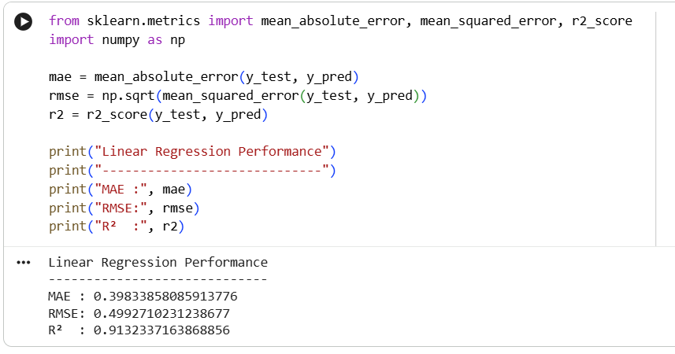
Figure 1: Model evaluation metrics generated during the predictive modeling process.

6. Visualization of Model Performance
Visualizations provide an easier way to communicate predictive model performance, particularly to stakeholders who may not have a technical background.

6.1 Actual vs Predicted Values
An Actual vs Predicted plot can be used to compare the crop yield values observed in the dataset with the values predicted by the model.
Ideally, predicted values should remain close to the actual values. A strong alignment indicates that the model is capturing the relationship between the input variables and crop yield reasonably well.
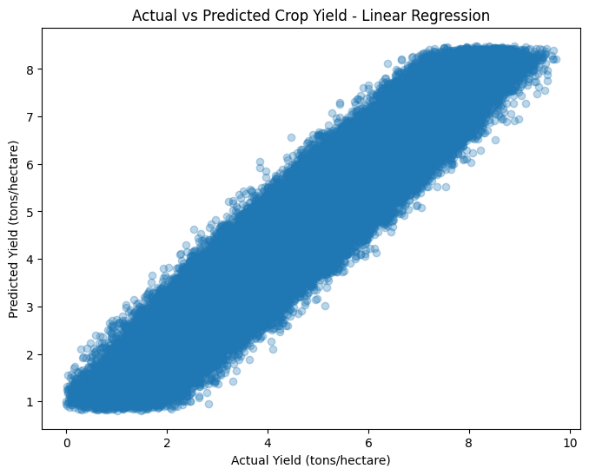
Figure 2: Actual versus predicted crop yield values.

Interpretation
The visualization provides a direct view of the model's prediction behavior. Predictions that remain close to the actual values indicate lower prediction errors. This makes the graph useful for communicating model performance visually in addition to numerical metrics.

7. Model Comparison
When multiple predictive models are developed, their performance should be compared using the same evaluation metrics.
The main criteria for comparison should include:
- Lower MAE
- Lower RMSE
- Higher R²
- Consistent performance on unseen data
A model should not be selected using R² alone. For example, a model with a high R² but relatively large prediction errors may not necessarily be the most useful model for practical agricultural applications.
The model comparison table should therefore provide stakeholders with a balanced view of predictive performance.
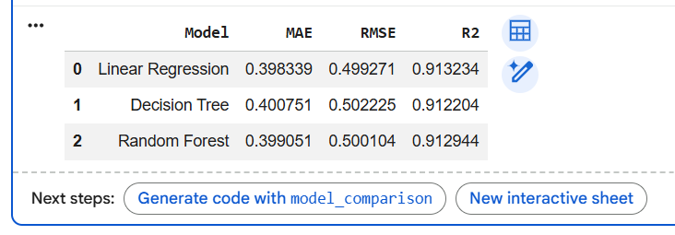
Figure 3: Comparison of predictive model performance.

8. Executive Summary
The evaluated Linear Regression model demonstrated strong performance on the available dataset. It achieved an MAE of 0.398339, an RMSE of 0.499271, and an R² of 0.913234.
The results indicate that the model can explain a substantial proportion of the variation in crop yield within the evaluated dataset. The prediction errors are also measurable in a practical unit, tons per hectare, making the results easier to interpret for agricultural stakeholders.
The model could potentially support activities such as crop planning, resource allocation, and yield estimation. However, the results should be treated as analytical support rather than as a replacement for agricultural expertise.
Before deployment in a real-world environment, the model should be tested on independent and more representative agricultural data.

9. Key Agribusiness Insights
The evaluation provides several useful insights for an agribusiness context:
- Prediction support: The model can provide estimated crop yields that may assist agricultural planning.
- Resource planning: Reliable yield estimates can help organizations plan the use of resources such as irrigation and fertilizers.
- Early decision support: Predictive information can potentially help identify expected yield patterns before harvest.
- Data-driven planning: The model demonstrates how environmental and agricultural variables can be used to support analytical decision-making.
- Need for continuous validation: Agricultural conditions change over time, so model performance should be monitored regularly.

10. Recommendations for Stakeholders
Based on the evaluation, the following recommendations are proposed:
- Use predictive results as decision-support information rather than as the only basis for agricultural decisions.
- Monitor model errors regularly after deployment.
- Retrain the model when sufficiently updated agricultural data becomes available.
- Validate predictions across different regions, crops, and seasons.
- Combine model predictions with expert agricultural knowledge.
- Track situations where prediction errors are unusually high.
- Maintain proper documentation of model inputs, assumptions, and evaluation results.

11. Limitations
Although the evaluated model demonstrates strong performance on the available dataset, several limitations should be considered.

11.1 Dataset Representation
The dataset may not fully represent the complexity of real-world agricultural conditions. Different geographical regions, soil conditions, farming practices, and seasonal patterns may influence crop yield.

11.2 Limited Variables
Crop yield can be affected by many factors. Variables such as pest attacks, disease occurrence, soil nutrients, seed quality, farming practices, and extreme weather events may not be fully represented in the dataset.

11.3 Generalization
Strong performance on an evaluation dataset does not automatically guarantee the same performance on future or real-world data.

11.4 Model Assumptions
Linear Regression assumes a linear relationship between predictors and the target variable. Agricultural relationships can sometimes be more complex and non-linear.

11.5 Data Quality
The reliability of predictions depends on the quality and accuracy of the input data. Incorrect or outdated agricultural information can affect model performance.

12. Future Model Refinement
The model can be improved through the following approaches:

12.1 Additional Machine Learning Models
Other regression algorithms, including Random Forest, Gradient Boosting, and other suitable models, can be tested and compared with Linear Regression.

12.2 Hyperparameter Tuning
For models containing adjustable parameters, hyperparameter tuning can be performed to identify configurations that improve predictive performance.

12.3 Cross-Validation
Cross-validation can be used to evaluate whether model performance remains consistent across different subsets of the data.

12.4 Feature Engineering
Additional meaningful features can be created from existing variables to improve the model's ability to identify relationships in the data.

12.5 Additional Agricultural Data
Future versions of the model could incorporate more detailed information such as soil nutrients, pest and disease information, historical weather conditions, farming practices, and regional agricultural information.

12.6 Continuous Monitoring
If the model is eventually deployed, its performance should be monitored regularly to identify changes in prediction accuracy over time.

13. Reporting Strategy for Non-Technical Stakeholders
Technical model metrics should be translated into simple business language when communicating results.
Instead of presenting only:
R² = 0.913234
the stakeholder report should explain:
The model explains approximately 91.32% of the variation in crop yield within the evaluated dataset.
Similarly, instead of reporting only:
MAE = 0.398339
the report can state:
The model's predictions differ from actual crop yield by approximately 0.40 tons per hectare on average.
This approach allows stakeholders to understand the practical meaning of model performance without requiring advanced statistical knowledge.
Visualizations should also be kept simple, clearly labelled, and directly connected to the business question being addressed.

14. Suggested Reporting Framework
The final model report should communicate information in the following order:
Model Objective → Evaluation Metrics → Results → Visualizations → Key Insights → Recommendations → Limitations → Future Improvements
This structure allows stakeholders to understand:
- What the model was designed to predict.
- How its performance was measured.
- What the results indicate.
- What the results may mean for agribusiness.
- What actions can be considered.
- What limitations should be kept in mind.

15. Conclusion
Model evaluation is an essential part of the predictive analytics process. A model should not be considered useful simply because it produces predictions; its performance must be measured, interpreted, visualized, and communicated appropriately.
For the evaluated Linear Regression model, the MAE of 0.398339, RMSE of 0.499271, and R² of 0.913234 indicate strong performance on the evaluated dataset.
The evaluation framework presented in this report combines quantitative metrics, visual analysis, stakeholder communication, and consideration of limitations. This provides a structured approach for assessing predictive models in an agribusiness environment.
Future improvements should focus on testing additional algorithms, validating the model on independent agricultural data, incorporating additional relevant variables, and continuously monitoring model performance.
Overall, predictive analytics can provide valuable decision-support capabilities in agribusiness when model results are interpreted responsibly and combined with domain knowledge.

